YONHOO NITILE GLOVES
Medical Examination Gloves

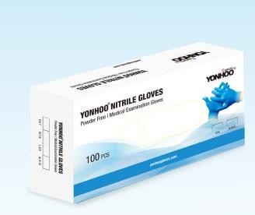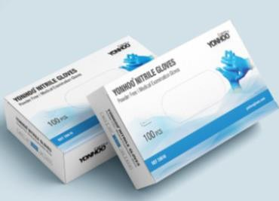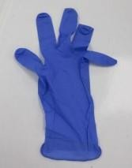

stock: 44.100 Units
Size XL: 11.430uds Size L: 25.170uds Size M: 7.500uds

Price: 3,75€ Boxes of 100 gloves Minimum request: 1000uds

